**Spring Core Maven**

**Exercise 1: Configuring a Basic Spring Application**

**Scenario:**

Your company is developing a web application for managing a library. You need to use the Spring Framework to handle the backend operations.

## **Step 1: Set Up a Maven Project**

### **Create the Project Structure**

You can use an IDE like Eclipse, or VS Code.

* Project Name: LibraryManagement

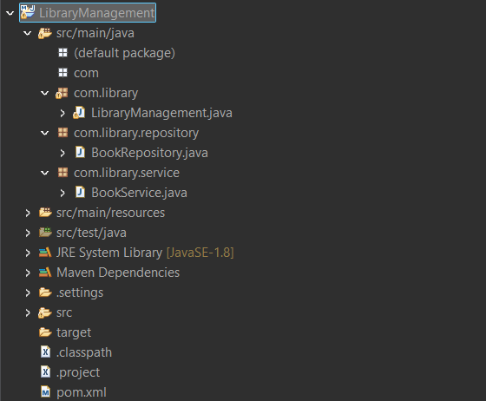

## **Step 2: Add Spring Core Dependencies in pom.xml**

Paste the following into your pom.xml:

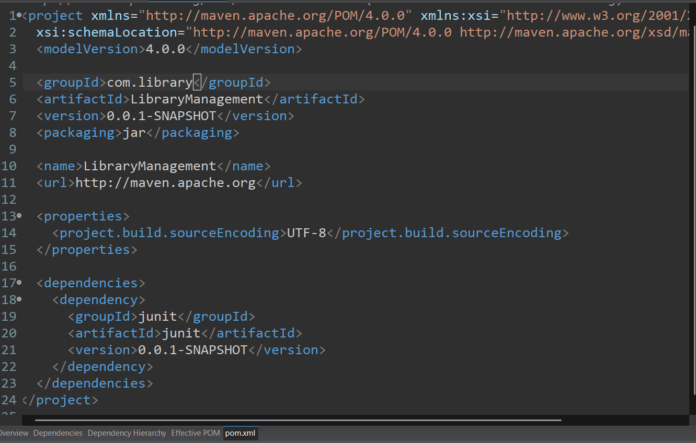

## **Step 3: Configure the applicationContext.xml**

Create the file:  
 src/main/resources/applicationContext.xml

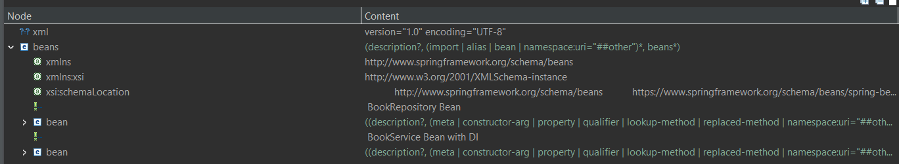

## **Step 4: Create Java Classes**

### **BookRepository.java**

File: src/main/java/com/library/repository/BookRepository.java

### **BookService.java**

File: src/main/java/com/library/service/BookService.java

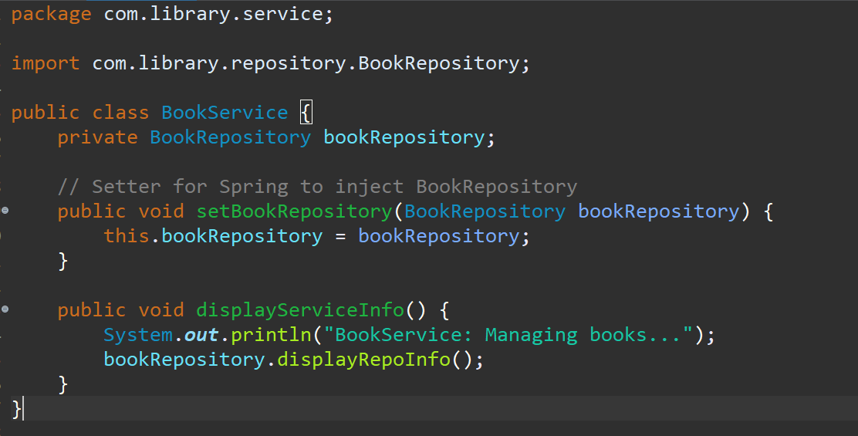

## **Step 5: Run the Application**

### **LibraryManagement.java**

File: src/main/java/com/library/MainApp.java

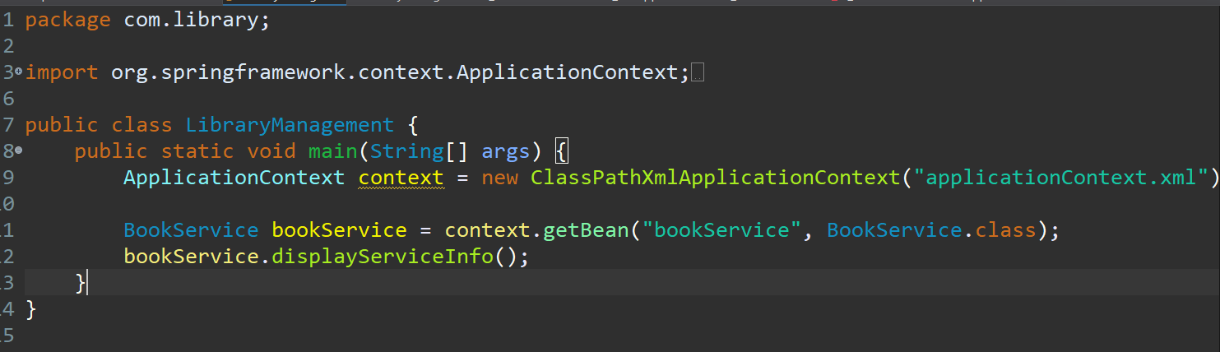

## **Step 6: Output**

Run the program to get the output

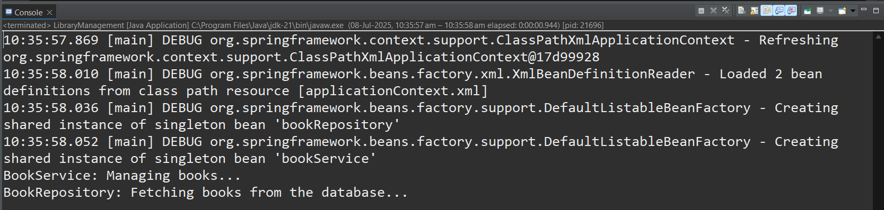

**Exercise 2: Implementing Dependency Injection**

**Scenario:**

In the library management application, you need to manage the dependencies between the BookService and BookRepository classes using Spring's IoC and DI.

### **✅ Step 1: Define the BookRepository Class**

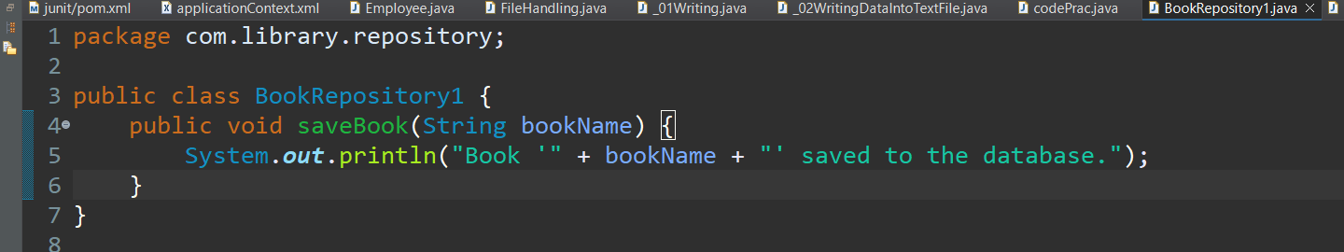

### **✅ Step 2: Define the BookService Class with Setter Injection**

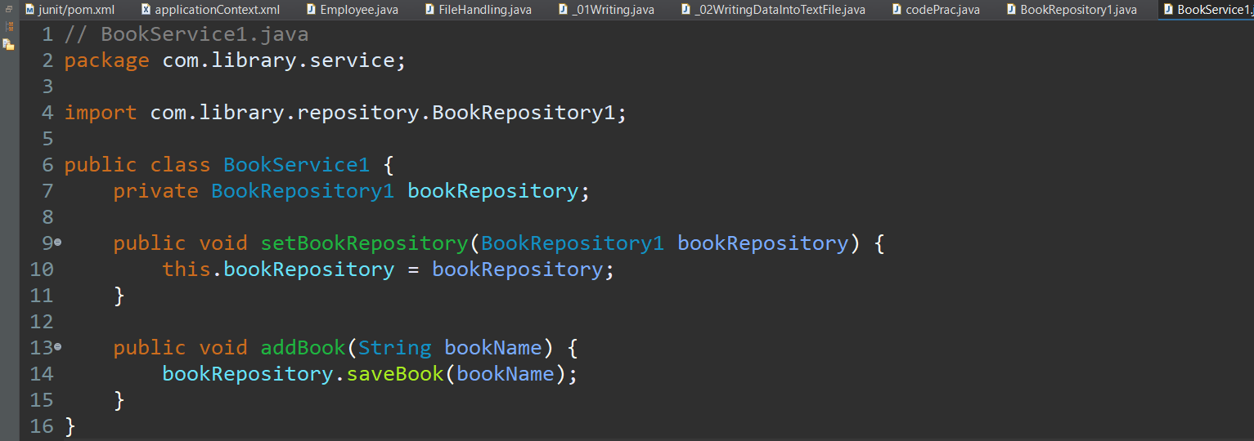

### **✅ Step 3: Update applicationContext.xml**

Make sure this XML file is located in your src/main/resources or classpath.

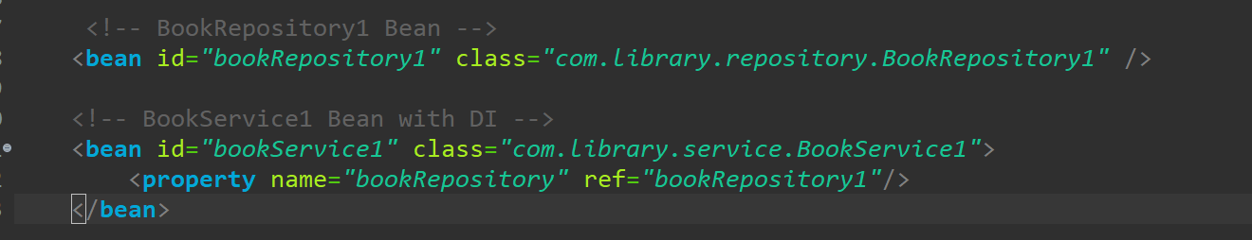

### **✅ Step 4: Create the LibraryManagementApplication Main Class**

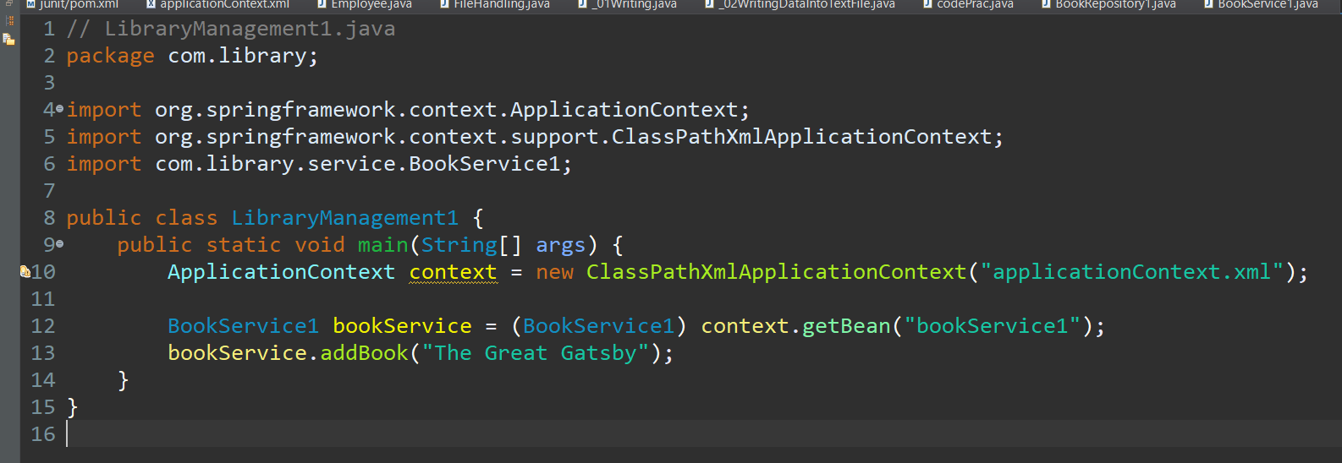

### **✅ Step 5: Run the Application**

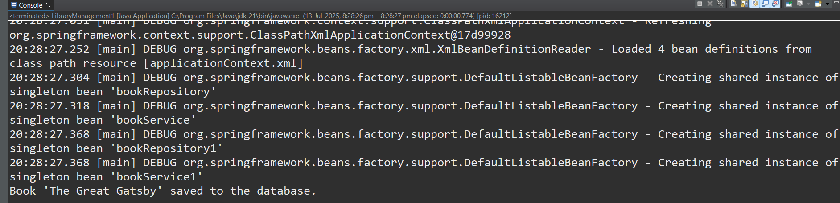

**Exercise 4: Creating and Configuring a Maven Project**

**Scenario:**

You need to set up a new Maven project for the library management application and add Spring dependencies**.**

## **✅ Step 1: Create a New Maven Project**

### **Option A: Using IDE (e.g., IntelliJ IDEA, Eclipse)**

1. Open your IDE.
2. Choose **New Project > Maven**.
3. Enter:
   1. **Group Id:** com.library
   2. **Artifact Id:** LibraryManagement
4. Set **Java version** to 1.8 if prompted.
5. Finish to create the project.

## **✅ Step 2: Add Spring Dependencies to pom.xml**

Replace the Spring version with the latest 5.x version if needed, but **avoid Spring 6** unless you're using Java 17+.

## **✅ Step 3: Project Directory Structure (Standard Maven)**

After setup, your project structure should look like:

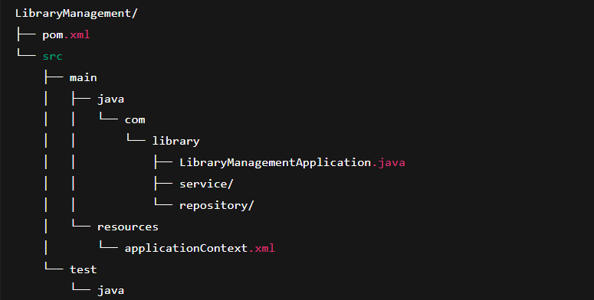**✅ Step 4: Build the Project**

Use the following command to compile and check for issues:

mvn clean install

**Mohammed Ayaan**

**Supersetid – 6409789**